Notes from waste Meeting 1st November 2022 & Councilors Update 2nd November 2022
- Action from previous meeting on 8th August 2022

- Melfort Avenue - The fence which was to be altered around the old phone box by the Rec boundary has still not happened and no update has been received by the council as to when this would take place. Fly tipping is continuing to be a problem there.

- 97 Melfort Road- Planning enforcement have been to visit the property and have concluded that the owner is in breach of the planning refusal, and that formal proceedings should be taken against the owner. However, the original planning officer who inspected the property is due to leave the council at the end of November, so a new case officer has been allocated to deal with this problem. Jeet Bains, the cabinet member responsible for planning, has also been made aware of this situation and is taking the matter up with the planning department.

- 216-220 Brigstock Road has not yet started building, as they still have pre-commencement planning conditions that they have not yet submitted to the planning department. 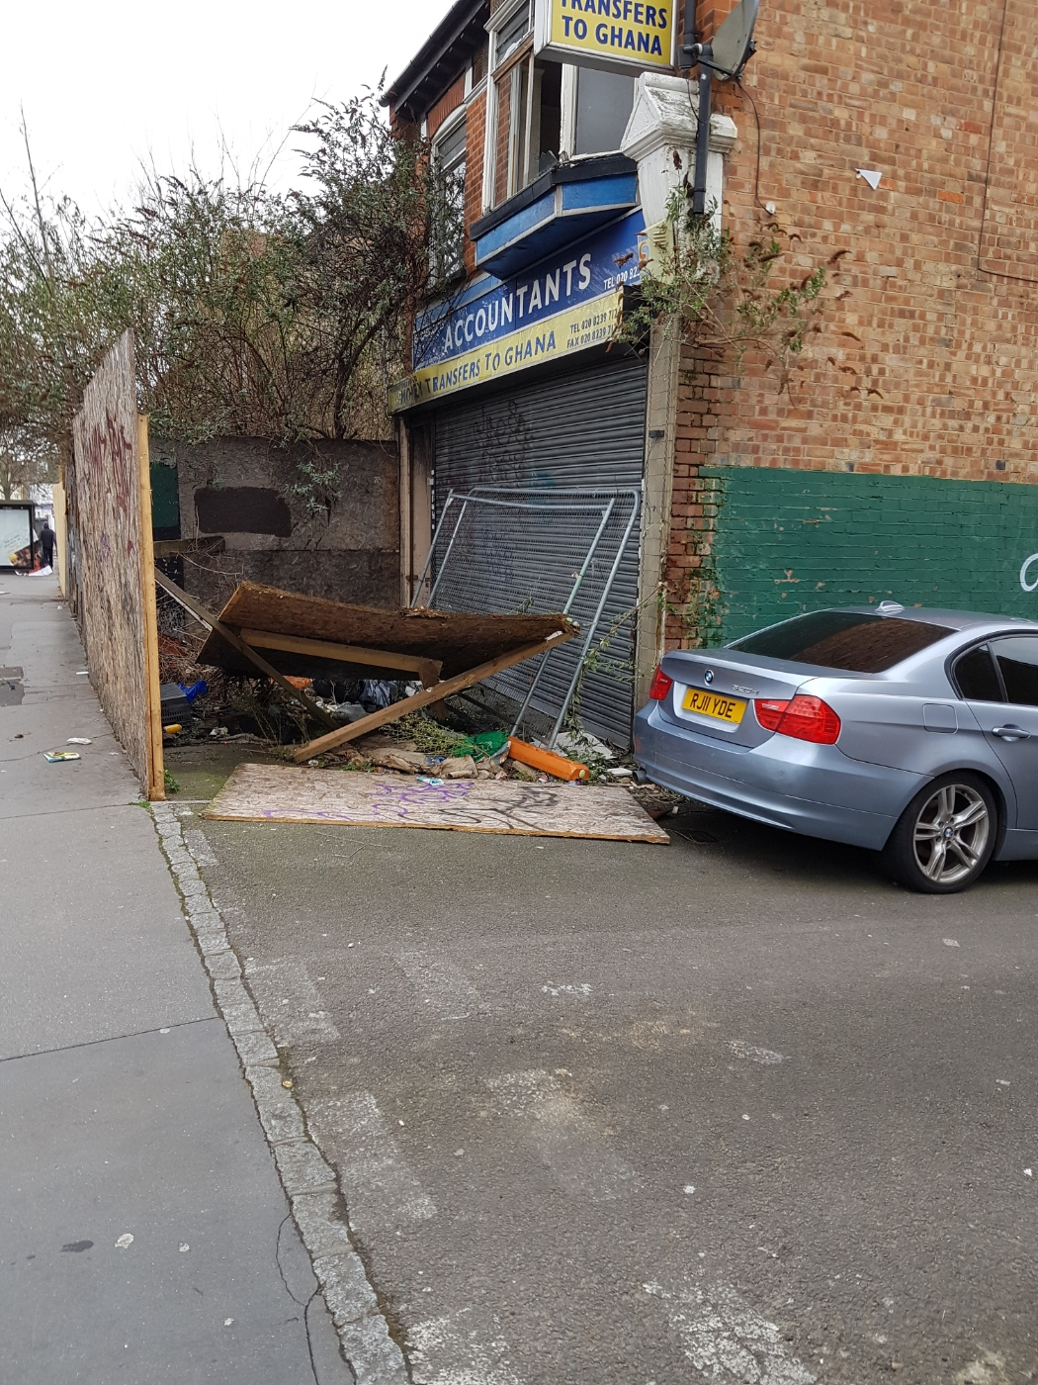The outer fencing, which came down in high winds earlier this year, has still not been repaired. THCAT have tried unsuccessfully to contact the owner,Mr Raza Jr, to request that this be rectified, and the area has progesively got worse over the past few weeks, so the council have issed a section 215 notice against the owners, which resulted in a new skip being placed in front of 216 Brigstock Road, but little else has been done.

- Brigstock Road Newsagents - It was suggested that the three news storage boxes be covered in self sticker posters available from Amazon. Gaetane will make enquiries to see what is feasible and affordable. (This is still ongoing)

- Trumble Gardens, Brigstock Road – A new Friends of Trumble Gardens has been established, and they carried their first action day on the 1st of October 2022 where a large contingent of volunteers helped to trim back the hedges, clear up the paths, and litter pick the area. The next action day is the 5th November 2022.

Scott Roche has also agreed to remove the benches from the park to help prevent ASB, and has requested that the grass be cut prior to the 5th November to coincide with the next clean up.

- Review of the outstanding items from the walkabout on the 2nd August 2022

- British Telecom Exchange building – 147 Brigstock road CR7 7JP, still has issues with looking unkempt. Although BT have cleared the overgrown weeds to the front of the building, the slabs still have weeds between them, which makes the area look unkempt. The councillors have been in touch with BT to try and find a responsible person who they can talk to, to try and agree a way forward to improve the area. THCAT will also see if they can find out who to talk to.

- The overflowing bins in Raymead Passage (near Raymead Avenue) continue to be a problem, and again Councillors Janet Campbell & Stuart King have taken this up with the Council. THCAT would suggest that maybe more bins were required to stop the overflowing of the current bins, or maybe a lock could be put on the bins to prevent them from being overfilled?

- The rubbish at 197-200 Brigstock Road continues to be removed, but the area becomes overflowing again within a few days, Councillor Humayun Kabir is asked if he could talk to the residents to try and prevent this from occurring.

- 179 Brigstock Road- The councillors have confirmed that, as part of the planning permission, the ground floor needed to be commercial shops. However, the owner has failed to find anyone willing to take on these premises. THCAT would suggest that the planning department look at relaxing this requirement and allow these commercial premises to be converted into flats.

- How do we deal with illegal HMOs and Rented Properties?

- We need a formal strategy from the Council explaining how these properties will be dealt with, and who we should deal with to ensure compliance.
We currently believe that the following properties are being converted illegally into HMOs:
- 3 Quadrant Road CR7 7DB
- 89 Melfort Road CR7 7RT
- 91 Melfort Road CR7 7RT
- 97 Melfort Road CR7 7RT
The relevant council departments and local councillors should check if these assumptions are correct or not.

- Other issues

- The issue of other Councils renting properties in Thornton Heath was raised. It was suggested that Croydon Council should impose a surcharge on the other Councils to cover infrastructure enhancements generated by the added influx of Council tenants, for services such as education, waste collection etc.

- Community Trigger, also known as ASB Case Review, is a service provided by all Local Councils to monitor ASB complaints that occur repeatedly over a six-month period. This service is not widely publicised, and it was felt that better communication about its existence would be beneficial to the community. More details can be found on Croydon Council website:
https://www.croydon.gov.uk/community-and-safety/safety/crime-and-antisocial-behaviour/community-trigger
This service has been utilised to highlight the ASB going on in Thornton Heath Rec with loud music and parties taking place most afternoons and evenings.
- Next walkabouts

It was agreed that the next walkabout would be in Thornton Heath Ward towards the end of November early December, date to be agreed.

THCAT Fly-tipping Team – Barbara, Gaëtane & Paul

